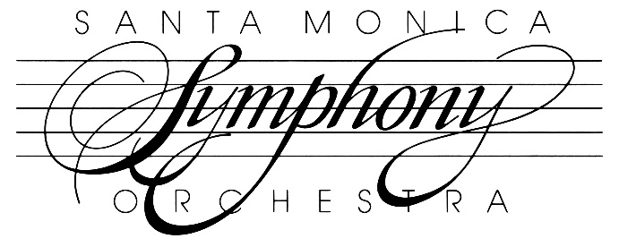
Corporate Sponsorship
The Santa Monica Symphony (SMS) welcomes opportunities to partner with local businesses and corporations to continue our long-standing tradition of bringing free classical music concerts to residents of Santa Monica and the surrounding area.
There are several ways for businesses to help us keep the work of the Symphony going. These include: purchasing an ad in our season program book, giving a donation to help cover our operating expenses, sponsoring a children’s outreach event, sponsoring our annual spring fundraiser, and sponsoring a concert. The Symphony is happy to provide one hour of free chamber music performed by SMS musicians as an expression of our thanks for donations of $5,000 or more. Additionally, the Symphony is always trying to spread the word about our events, and it would help us greatly if you would be willing to feature our season brochure at your place of business.
Purchasing Season Program Book Ads
The Symphony produces 6,000 beautiful color program books each season that are distributed at our concerts throughout the year. Inside are spaces for full, half, and quarter page advertisements. The prices and deadlines to submit art and text for your advertisement run as follows:
Ad Size | Price | Deadline for Submission
Quarter Page Ad | $400 | September 1
Half Page Ad | $750 | September 1
Full Page Ad | $1200 | September 1

Sponsoring a Children’s Outreach Event
The Santa Monica Symphony believes it is of utmost important to be sharing classical music with the next generation. It is our goal to organize 1-2 special outreach events in the Santa Monica public schools each year where a string quartet comprising SM Symphony players visits one of the schools, gives a little concert, and teaches the students about rhythm and dynamics and how to listen for musical themes. You can sponsor the entire event with a donation of $2,000, or give a smaller amount for a partial sponsorship. Sponsorships of at least $500 will receive placement on our event flyers, our social media outlets, and other publicity for the event. If you wish to sponsor one of our events, please let us know at least 1 month prior to the event.
Sponsoring the annual SMS Fundraiser
Every spring, the Santa Monica Symphony hosts an elegant event for about 100 people featuring chamber music, wine, and heavy h’ors d’oevres to raise funds for our concert season. This year, it was held at Mayor Riordan’s lovely home, and violinist Vijay Gupta from the LA Philharmonic will be present as a special guest performer. We are always looking for sponsors who might be willing to offer a venue we could use for this occasion. Businesses are also welcome to partner with us by covering the costs of (or providing an in-kind donation) of catering, wine, or items for our silent auction. For a full sponsorship of the event ($8,000) we can provide your business with the following:
- Advertising your business in the publicity announcements for the event on our website, social media outlets, and other publicity advertising the event
- Placing your company’s logo on our signage for the event
- Public thanks of our company during announcements at the event
- A full-page ad in our symphony program booklet
- a 1 hour concert by an SMS chamber ensemble at your business or other preferred location
For a partial sponsorship of the event ($4,000) we can provide your business with the following:
- Advertising your business in the publicity announcements for the event on our website, social media outlets, and other publicity advertising the event
- Placing your company’s logo on our signage for the event
- Public thanks of our company during announcements at the event
- A half-page ad in our symphony program booklet
Please inquire with our Director of Development, Tabitha Hogue, for more details.
Sponsoring a Concert
Corporations or large businesses who would like to sponsor a concert can give us a gift of $10,000 that will be designated for one of our five concerts during the year. The Santa Monica Symphony will provide these corporate sponsors with the following:
- a full-page color ad in our season program book ($1200 value)
- providing a 1 hour concert by an SMS chamber ensemble at your business or other preferred location
- placement of your logo on our web site
- printing your logo on our program insert for the concert
- acknowledging your business during our pre-concert announcements
- naming your business as our sponsor in our Santa Monica Mirror article prior to the concert
- promoting your business as our sponsor on our Facebook and Instagram posts leading up to the concert
In return for a partial sponsorship of $5,000, the Symphony can provide the following for your business:
- a half-page color ad in our season program book ($750 value)
- providing a 30-minute concert by an SMS chamber ensemble at your business or other preferred location
- placement of your logo on our web site
- printing your logo on our program insert for the concert
- acknowledging your business during our pre-concert announcements
- naming your business as our sponsor in our Santa Monica Mirror article prior to the concert
- promoting your business as our sponsor on our Facebook and Instagram posts leading up to the concert
Deadlines: If you wish to be a full or partial sponsor for one of our concerts, please let us know at least 1 month prior to the concert.
Platinum Circle Gifts
If your company is interested in giving a gift greater than $10,000, please contact Tabitha Hogue at (310)395-6330 for information about special Platinum Circle benefits.

