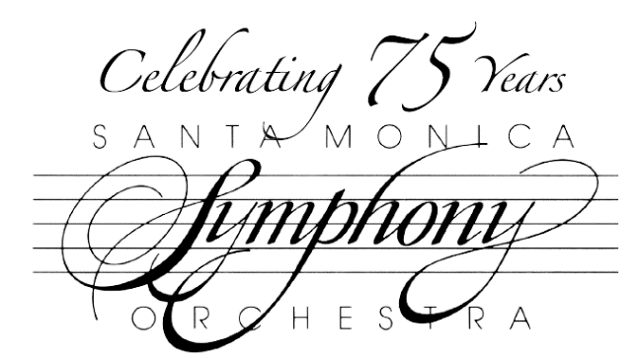
P.O. Box 3101
Santa Monica, CA 90408-3101
(310) 395-6330 ⬧ www.smsymphony.org

2019-2020 Season Program Book
ADVERTISEMENT ORDER INFORMATION

Celebrate the Santa Monica Symphony’s 75th season!
Support FREE live concerts of outstanding classical music for our community.
Reach an audience of over 5,000.

FORMAT OF PROGRAM BOOK: 8.5 x 11 inches
Please provide camera-ready art (PDF file 300 dpi)
Send to: info@smsymphony.org

Ad Sizes and Prices

Placement size (in inches) Price
□ Back Outside Cover (color) 8.5 x 11* $5,000**
□ Front Inside Cover left side (color) 8.5 x 11* $5,000**
□ Rear Inside Cover right side (color) 8.5 x 11* $3,000**
□ Rear Inside Cover left facing page 8.5 x 11* $3,000**
□ Inside full page 8.5 x 11* $1,200
□ Half page (horizontal) 7.5 x 4.75 $ 750
□ Quarter page (vertical) 3.5 x 4.75 $ 400

** includes your business logo on Symphony mailings and website

* Plus 1/8” bleed all sides

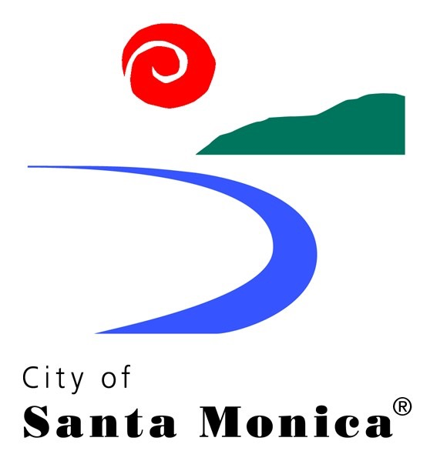
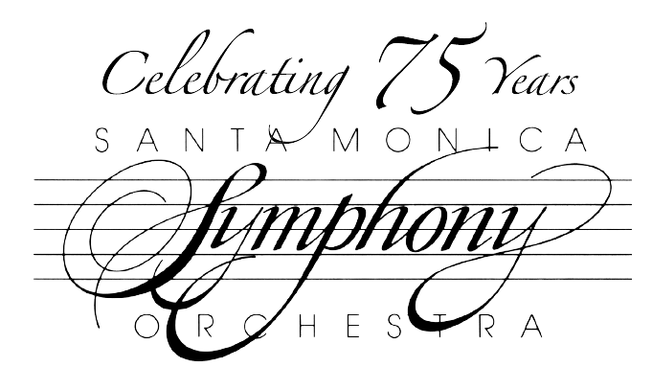
2019-2020 Season Program Book
ADVERTISEMENT ORDER FORM

Please Note: Deadline for ad commitment is September 2, 2019
Deadline for artwork is September 13, 2019

Advertiser Business Name________________________________________________

Advertiser Representative Name ___________________________________________

Address ______________________________________________________________

City/State/Zip______________________________Email ________________________

Telephone ( )_______________________Fax ( )_________________________

Signature of Advertiser ______________________________Date: _______________

Amount of Payment $__________________________________________________

□Check □PayPal □Visa □MasterCard □AMEX

Number ___________________Expiration Date (mo/yr)_______Security Code_______

Name on card __________________________________________________________

Billing address _________________________________________________________

City/State/ZIP __________________________________________________________

PayPal/Credit Card option available at: www.smsymphony.org - on home page click SUPPORT
□ Please send us an invoice □

Email this form along with your camera-ready advertisement to:
info@smsymphony.org

Please call with questions (310) 395-6330. Thank you!

